***“Heaven’s Light is Our Guide”***



**Department of Computer Science & Engineering**

**RAJSHAHI UNIVERSITY OF ENGINEERING & TECHNOLOG**

**Lab Report**

**Submission Date: 10-10-2024**

|  |
| --- |
| **Submitted By:**  **Name: Khandoker Sefayet Alam**  **Roll:2003121**  **Department: Computer Science & Engineering**  **Section-C**    **Course code: CSE 3106**  **Course name:** Computer Interfacing and Embedded Systems Sessional |

|  |
| --- |
| **Submitted To:**  **Md. Farhan Sakib**  **Lecturer**  **Department of Computer Science and Engineering,  RUET** |

**Experiment-01:**

**Title :** Interfacing an 8086 microprocessor with I/O Devices and Blinking an LED.

**Theory:**

1. Intel 8086 Microprocessor:

Intel debuted the 8086, a 16-bit microprocessor, in 1978. Located in a 40-pin Dual Inline Packaged IC, the 8086 is a 16-bit integer processor. The 20-bit address bus 8086 enables it to

access a 16-bit data bus for data handling and up to 1 MB of memory. It is adaptable to various programming requirements because it supports multiple addressing modes and instruction sets. General-purpose registers, segment registers for memory management, and instructions with dual arithmetic and logical operation optimizations are all part of its architecture.

We require an extra latch to keep the address bits when the CPU is supplying data across the bus because it has a higher 16-bit address bus and a 16-bit data bus that are multiplexed.

2. Programmable Peripheral Interface (PPI):

An adaptable I/O device called the Programmable Peripheral Interface (PPI) enables the 8086 to communicate with external parts like keyboards and ADCs (Analogue to Digital Converters) and DACs (Digital to Analogue Converters). Three 8-bit bidirectional I/O ports (PORT A, PORT B, and PORT C) on the PPI can be independently configured to be input or output ports. Because of its versatility, the PPI may be used in a wide range of applications and facilitates smooth communication between peripheral devices and microprocessors.

3. 74HC373 Latch:

To capture and hold the address during the address phase of an 8086 while data is being sent, external latches are required. The I/O device would operate incorrectly if these latches were missing because it would be unable to discriminate between address and data. The 74HC373 latch's main function is to divide and retain the address lines' lower 16 bits from the multiplexed address/data bus.

**Code:**

**DATA SEGMENT**

**PORTA EQU 00H**

**PORTB EQU 02H**

**PORTC EQU 04H**

**PORT_CON EQU 06H**

**DATA ENDS**

**CODE SEGMENT**

**MOV AX,DATA**

**MOV DS, AX**

**ORG 0000H**

**START:**

**MOV DX, PORT_CON**

**MOV AL, 10000000B**

**OUT DX, AL**

**blinkloop:**

**MOV AL, 00000001B**

**MOV DX, PORTA**

**OUT DX,AL**

**MOV CX,0F424H**

**loopy1: loop loopy1**

**MOV AL, 00000000B**

**MOV DX, PORTA**

**OUT DX,AL**

**MOV CX,0F424H; Delay**

**loopy2:loop loopy2**

**JMP blinkloop**

**CODE ENDS**

**END**

**Screenshots:**

1. **LED on:**

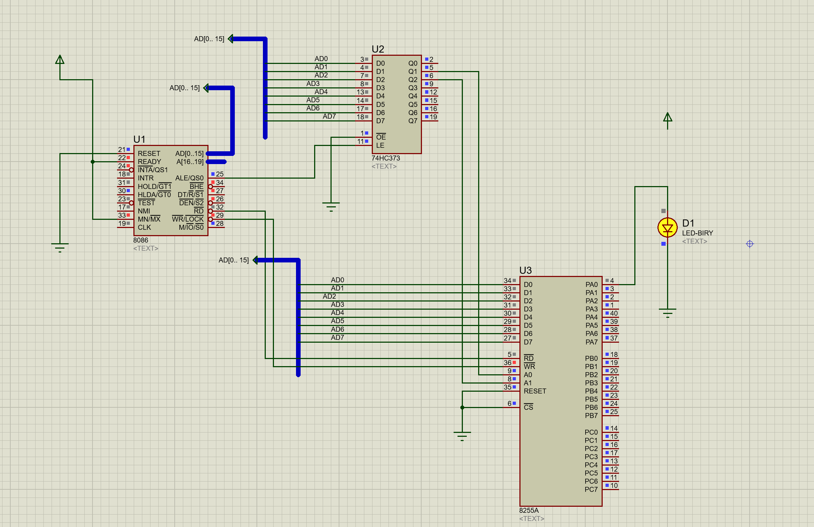

1. **LED off:**

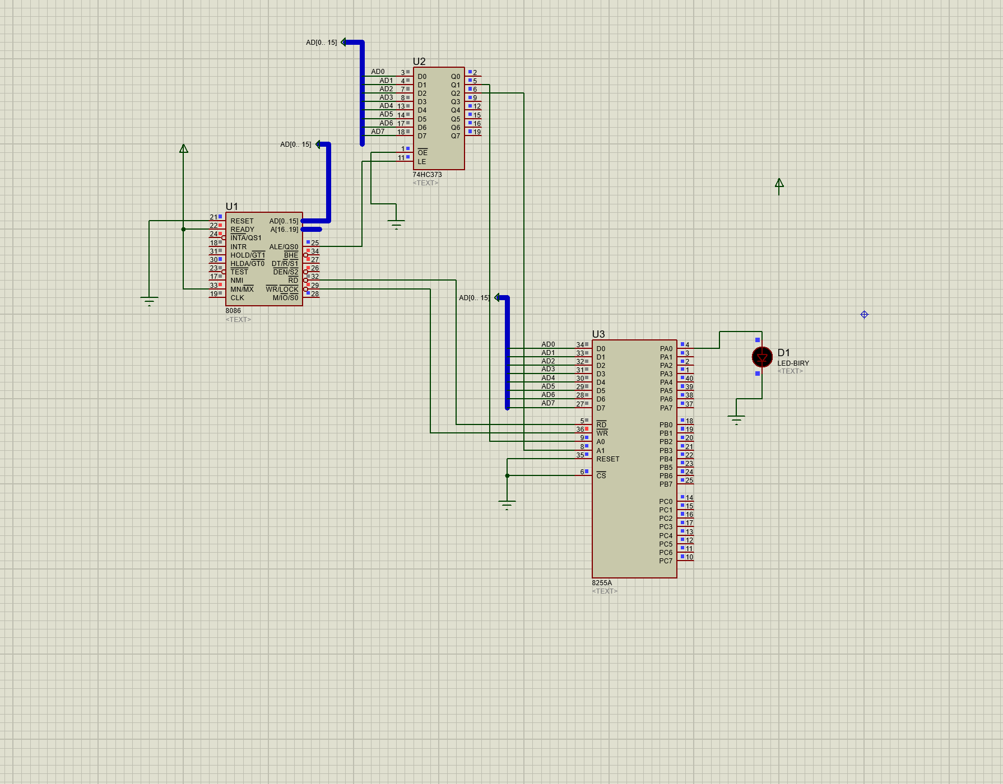

**Conclusion:**

We successfully connected an 8088 CPU with I/O devices to control the blinking of an LED, in our project experiment using Emu8088 for programming in assembly language and Proteus for simulation purposes to demonstrate how the 8088 microprocessor interacts with devices, like components. Through this exercise we deepened our comprehension of I/O interface concepts. Learned how control signals are applied to manage external hardware components effectively.

During the session we had recently done together with our instructor team to learn assembly code, for managing hardware functions was indeed quite insightful! It clearly demonstrated how microprocessor programming plays a role, in embedded systems by showcasing real world applications in action. The fact that the LED started blinking as expected signified that both the hardware setup and programming logic were implemented accurately as planned. Affirmatively showing that our system was functioning correctly.